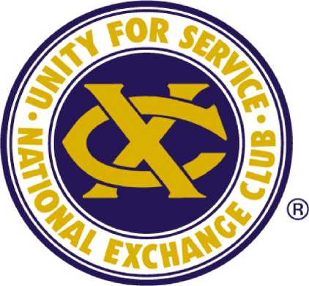

The Exchange Club of Augusta
2024 Guidelines for Unrestricted Grants
ABOUT THE EXCHANGE CLUB OF AUGUSTA
The Exchange Club of Augusta received its charter on August 8, 1923. Thirty-four young men wanted to EXCHANGE ideas, service, and fellowship, as well as their free time for service to their community. In the words of Mr. William M. Lester, a charter member, "It is our purpose to accomplish something worthwhile for our city, our state, and our country...We want to help the boys and girls of Augusta and the neglected child."
The Exchange Club of Augusta began running what is now known as the Georgia-Carolina State Fair in 1923. The Fair grew and moved to its current location in 1937. The object of The Fair was to raise money to be distributed back into the community. There were always so many worthy organizations and so much need in the community. Going back to the start, the members believed that children came first. In keeping with the National Exchange Club's dominant project, The Prevention of Child Abuse, the club now contributes largely to organizations dedicated to this cause. The Exchange Club of Augusta's fund-raising efforts now includes the CSRA Charity Golf Classic and donations from its members. The Exchange Club of Augusta awards grants based on identified community issues and the relative merit of the proposals received.
- WHO IS ELIGIBLE TO APPLY FOR UNRESTRICTED GRANTS?
The Exchange Club of Augusta's Donation Committee considers grant applications from organizations that:
- Are determined as Charitable under section 501(C)(3) of the Internal Revenue Code, public entities, or other charitable, educational, or cultural organizations.
- Provide programs and services within the counties that comprise the CSRA.

- WHAT CRITERIA SHOULD APPLICATIONS EMPHASIZE?
The Committee looks for proposals that:
- It will positively impact the lives of children.
- Develop competencies and skills enabling individuals to live fuller, more productive lives. Promote systems or approaches which can prevent individual, family, or community problems. Address a significant need affecting a broad segment of the area's population.
- Show specific outcomes that the funds will be used for (be specific)
- Show how the SPECIFIC results will be measured and reported to The Exchange Club of Augusta.
- CAN ORGANIZATIONS APPLY FOR CONTINUED FUNDING?
Usually, The Exchange Club of Augusta chooses to distribute the limited funds among many organizations over time. When the Donation Committee receives grant requests for continued yearly funding, they will analyze that request against all of the other grant requests received; however, the intent is to spread the funds throughout the community and to those that the Donation Committee deems to be the most beneficial to the entire CSRA for that year.
- HOW DOES AN ORGANIZATION APPLY FOR A GRANT?
Any 501 (C)(3) interested in seeking grant support should follow these steps:
Determine if your organization is eligible to compete for funds. Please submit any questions via email to donations@augustaexchangeclub.com.
Obtain an application by visiting our website at www.augustaexchangeclub.com, clicking on Community Outreach, then clicking on the link titled Grant Application. Submit your application before March 22, 2024, to donations@augustaexchangeclub.com. To be considered for a grant, recipients must complete all forms.

